It previously did not do the addition of lookalike audience

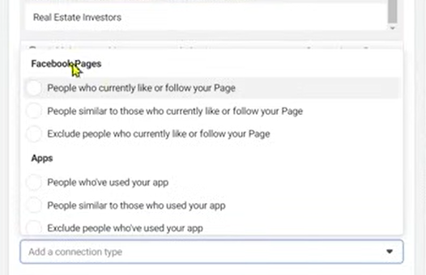

It gives option like above and hey are usually categorized into Facebook pages, Apps, Events

Sometimes through our facebook page we create event through which we ca create audience

So connetion actually help us to create custom or lookalike audience

**Lesson 32:-**

In this lesson we will learn about Interest based Audience

In this particular lesson we will see different ways through which we can collect different ideas for audience targeting Sometimes we come across many big challenges in Interest based targeting topics So in this particular lesson we will see two or more tools through which you can get better result .

The first way is

Finding the pages like by relevant profile

Here you can choose influencer name for targeting who are famous for a particular niche and then target them

Suppose there is an influencer famous for his/her digital marketing content then you can target them so that indirectly you can target there followers

Andthen go to their profile and then try to understand what pages they like

And you can analyse those pages and on the basis of these pages can you do targeting

So for Facebook profile

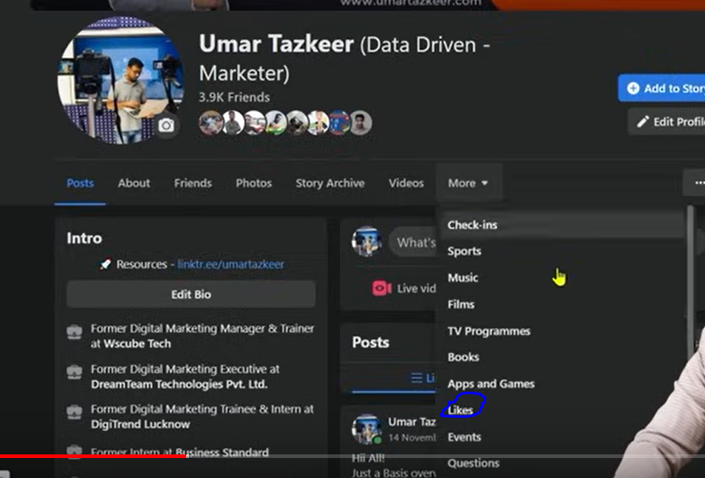

You click on more as shown above and then a submenu will be opened then go to Likes

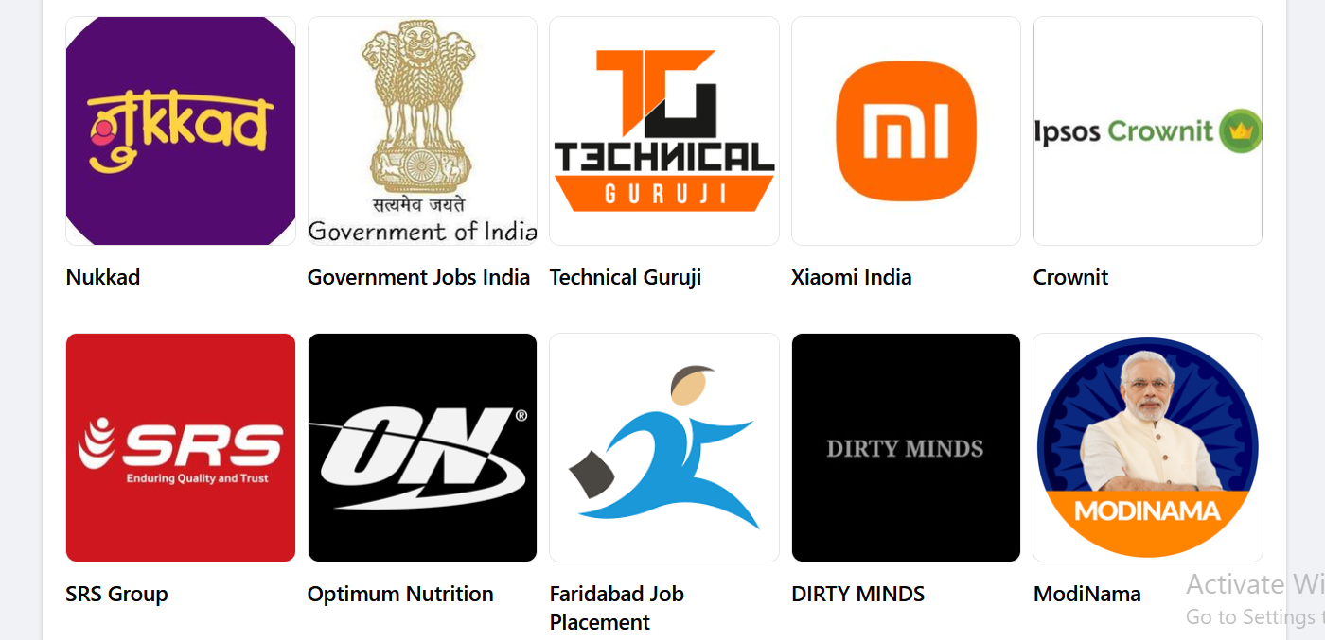Now you can see the list of liked pages

You can search those name in field of detailed marketing if it shows in suggestion then you can target them if it does not show that name in suggestion then you cannot target them.

Teacher is telling this because we don’t usually get any ideas while targeting in detailed targeting so that you can get maximum to maximum ideas so that you can niche down or narrow down you can get better to better audience

The second way is Niche book author targeting

Here if you want to target any particular field then you try to target them on the basis of the author who wrote book on that particular Field

Suppose we want to show ad to the people who is interested in Digital Marketing then we will target a digital marketing author Philip Kotler

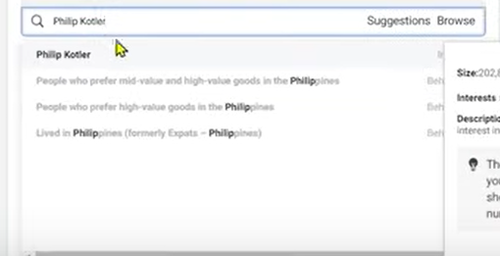

Publishers are not required but you can target authors.

You can target the famous author

Start relting between things

How through one interest other interests can also get targets.

And how one interest is related to other interest.

The more ideas you have of interest the better you can do targeting here.

**Phase 47**

**Lesson 33:-**

In this lesson we will learn about how to find **Hidden Facebook Audience**

Without paid tool

As we discussed tools in previous videos if you don’t want to use them then you have to put some effort and through that effort you can target those hidden interested audiences.

So there are some step provided by teacher but we are actually going to use market api to do it.

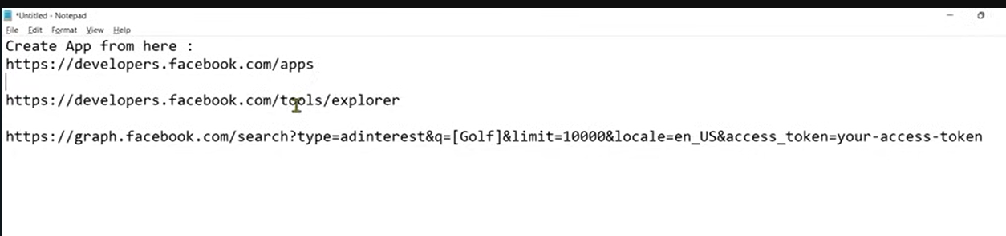

The above link we will use in future

Now first thing to do is to create App.

So what we have to do is follow the first link

But it will not open so follow the link removing /apps from the url

And then register and create developers account.

And follow the above images

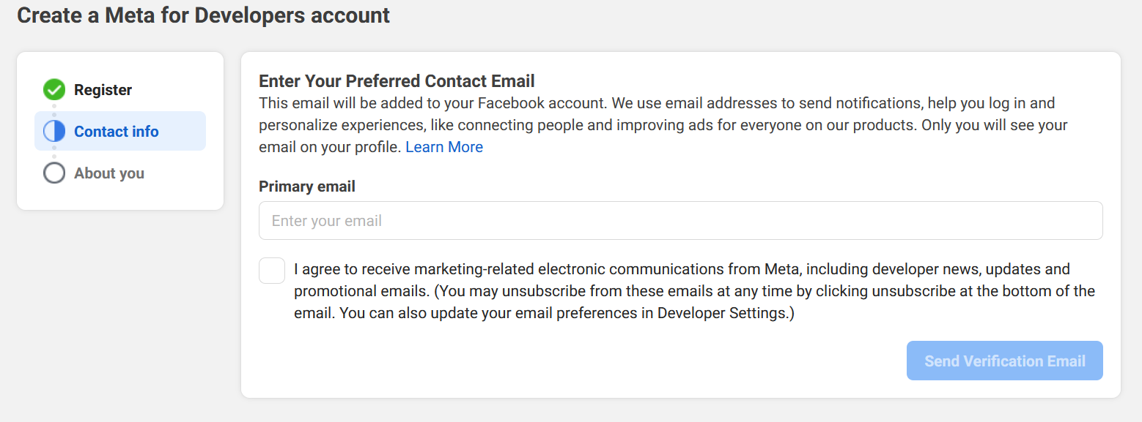

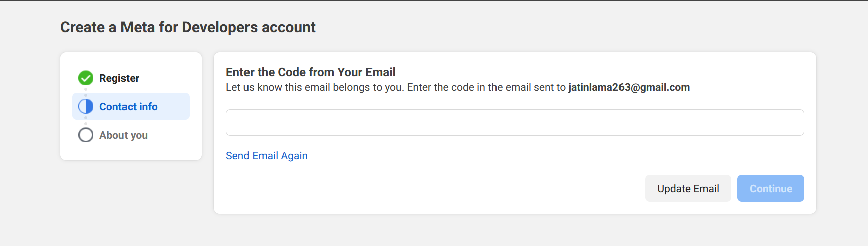

And then it will ask you what is your udentity are you a developer or marketer

After this you will be directed to the first url

Now it will show like this

below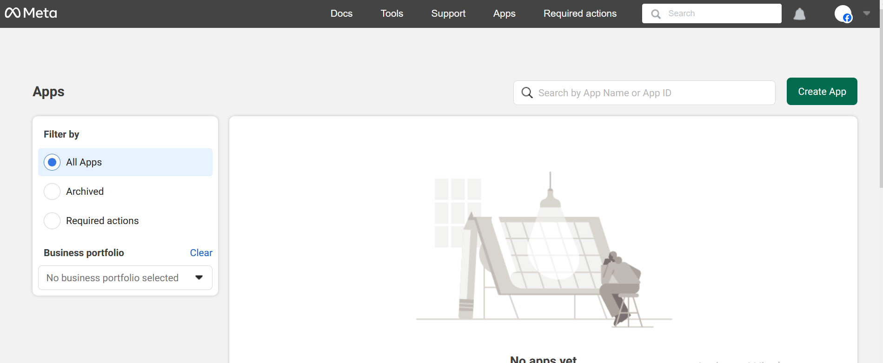

now you just need to click on create app

you will get the page below

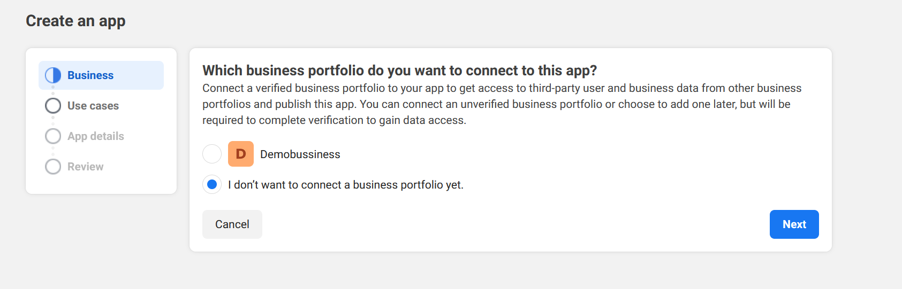

Asking to use Business Portfolio if you have one then check the radio button near it

Or you can click on I don’t want ot connect business portfolio yet.(I chose this)

And in next it will ask you what you want you app to do?

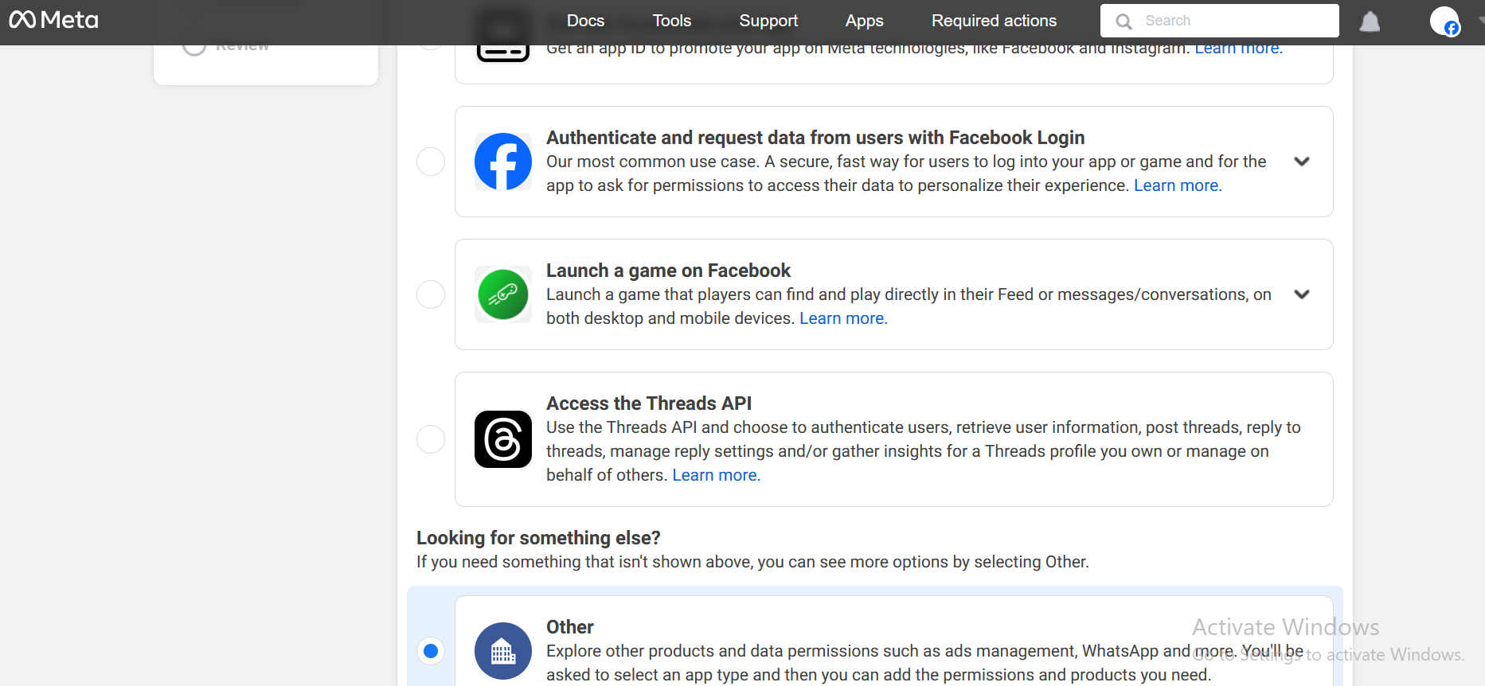

Click on next

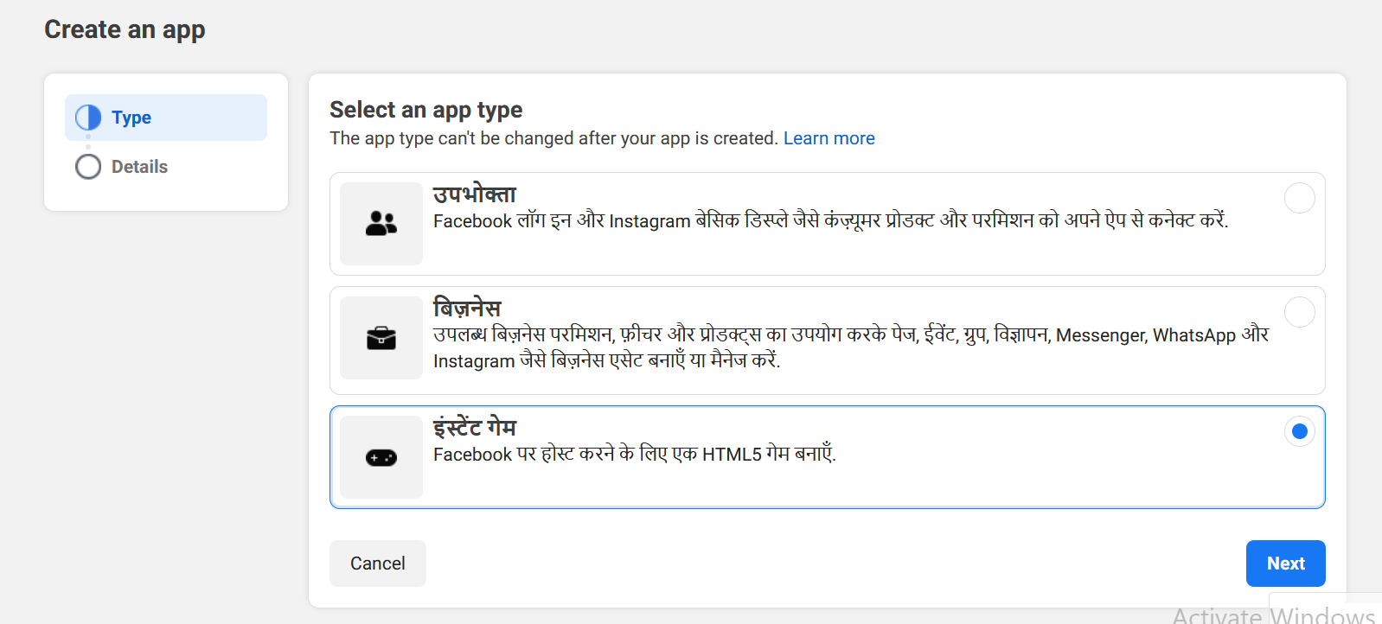

Now it will ask the type of the app you want to make

And give there option

Consumer type

Business Type

Instant Game

we choose instant instant game.

Click on next and now this page will be shown

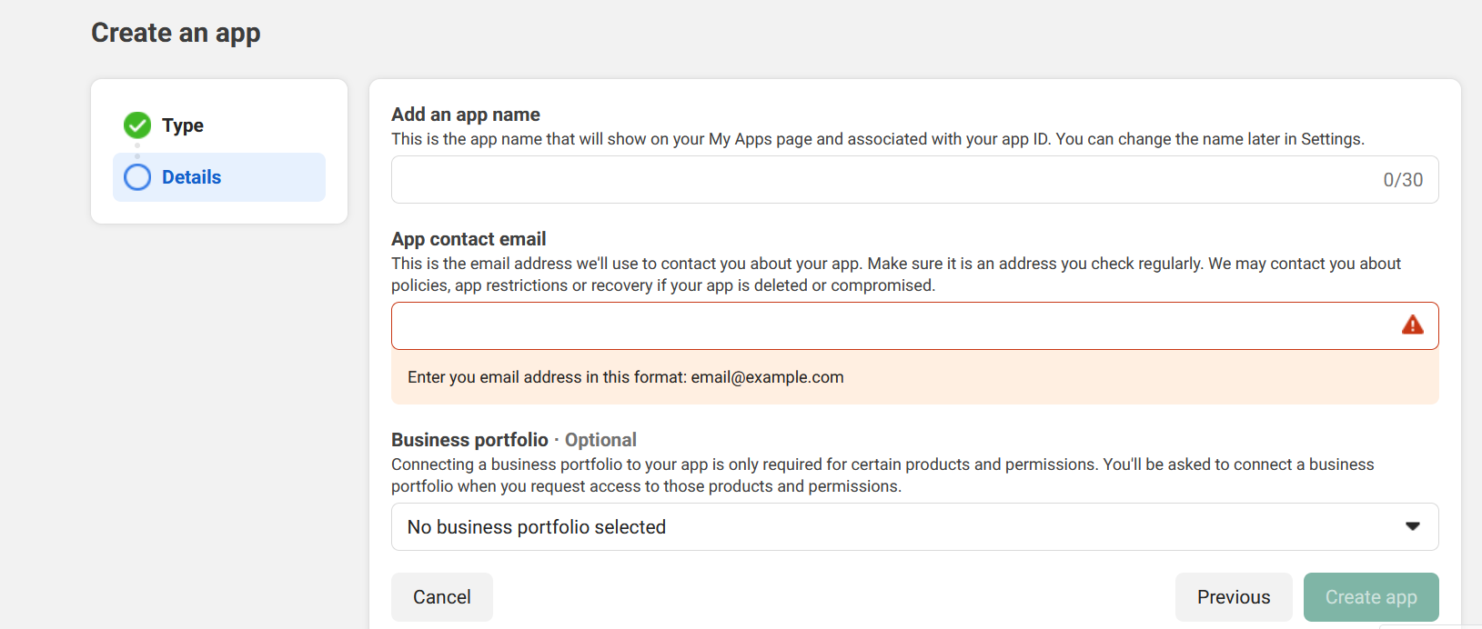

In first field tell the app name

And in second field app contact email

And in third choose business portfolio which is optional

After clicking on create App

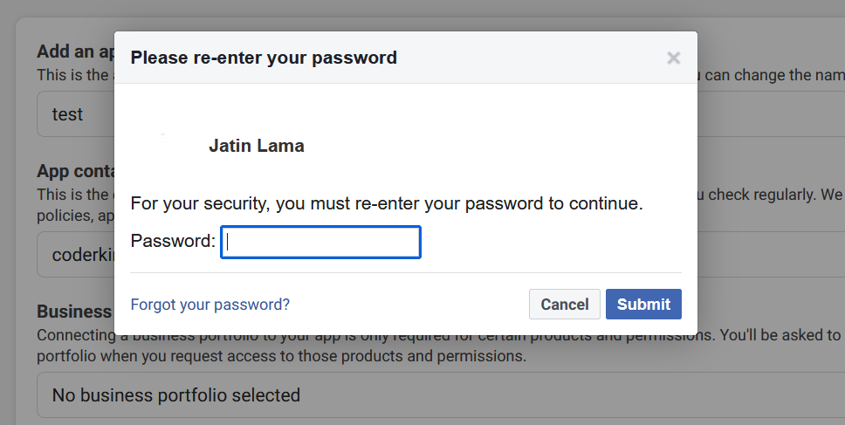

And now it will prompt you to enter the password

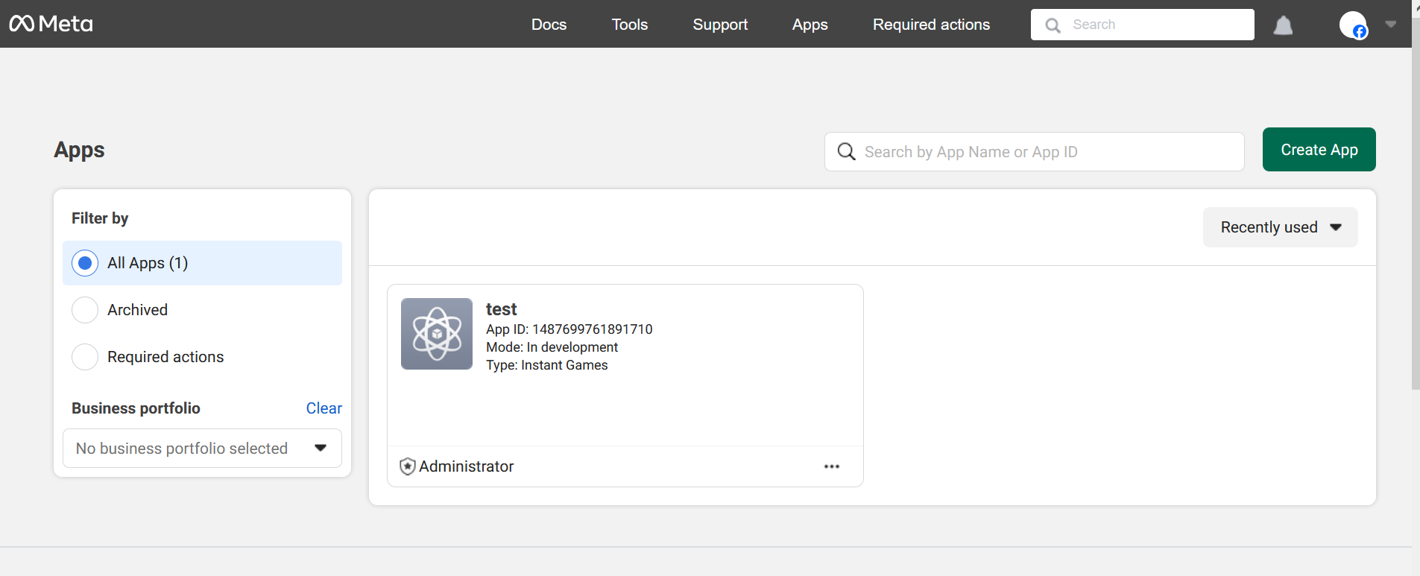

After this your app will be shown in app section

Now go to the url below

<https://developers.facebook.com/tools/explorer>

and you will get the screen below

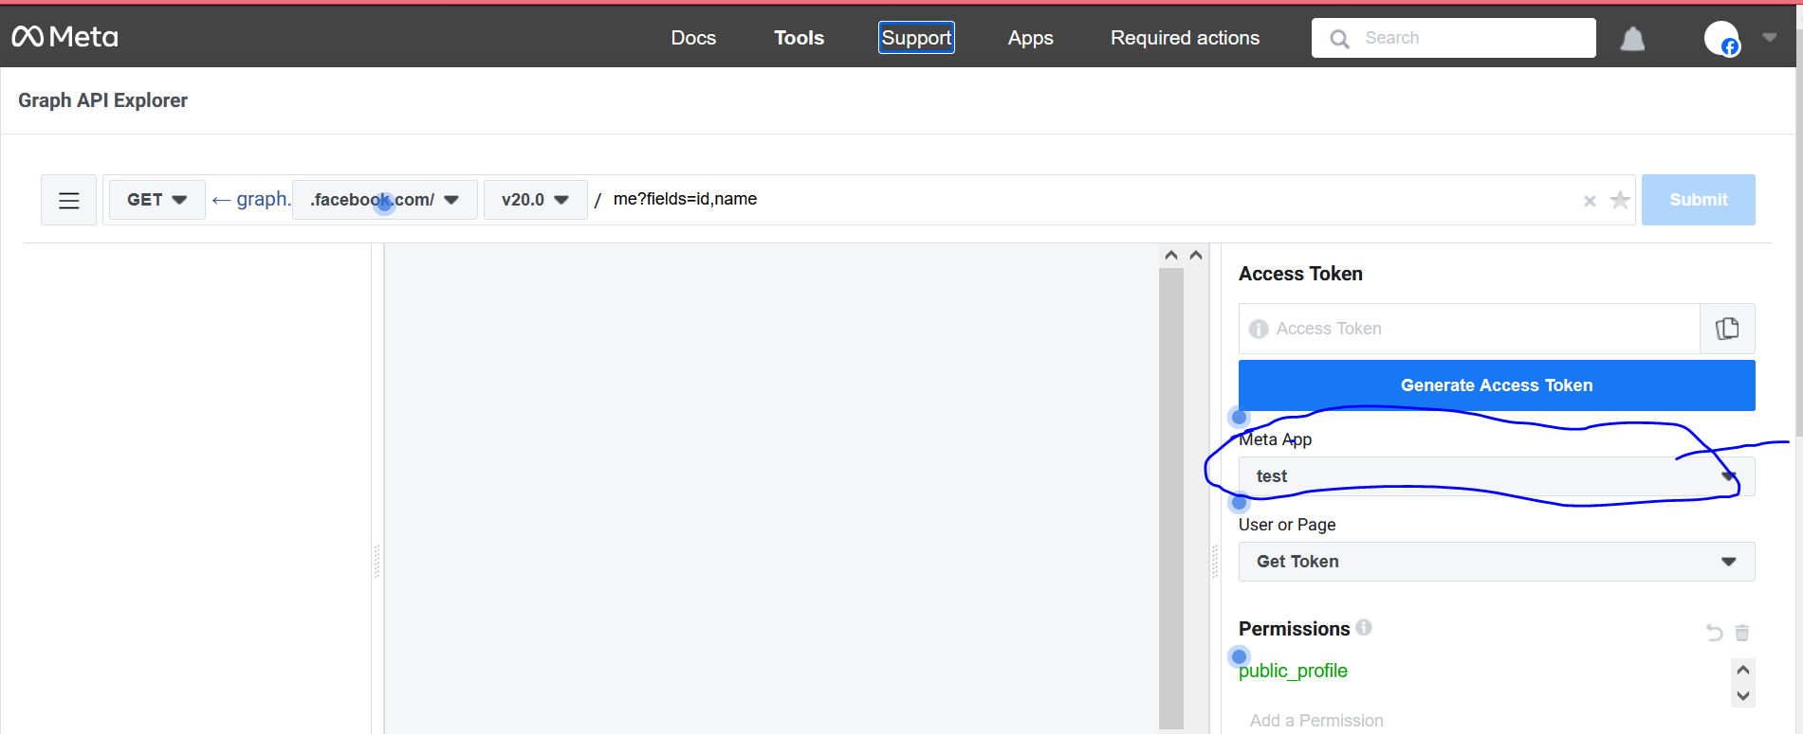

Choose you’re app in above marked

Click on generate Access Token

And you will get the token in above field and then copy it and then paste it in the end of the url below

[https://graph.facebook.com/search?type=adinterest&q=[Golf]&limit=10000&locale=en_US&access_token=access_token](https://graph.facebook.com/search?type=adinterest&q=%5bGolf%5d&limit=10000&locale=en_US&access_token=access_token)

now you will get the result as api like below

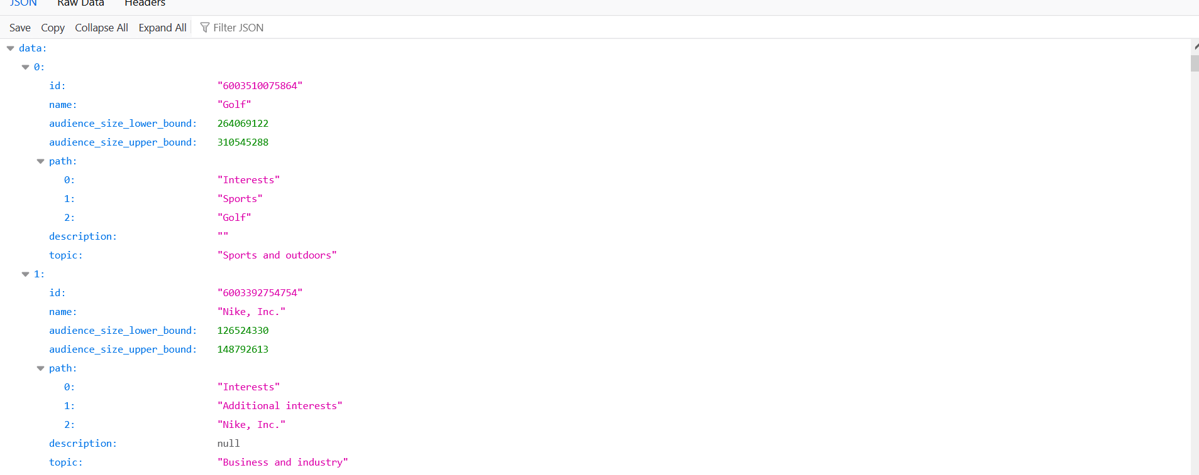

In the above url In place of golf you can keep any primary interest but it should start with the capital letter

It will show you related interest(hidden audience) according to api as above

And now you can use any interest to find there hidden audience  
The paid tool exist because they categorise these interest

You don’t have to do categories api by yourself because them and they make your work very easy.

The more the sources you can collect to find beter and better audience this is good for you and it will also be good for the testing

**Lesson 34:-**

In this lesson we will learn about Facebook Cold audience

What things are better

What are the points or learning we can take from the discussion till now

Follow these points a guidelines or you can say it some rule of thumbs that have been finalized from our discussion till now related to audience

The first point is Don’t be too narrow and don’t be too Broad

Means your audience should not be less than 1000 and your audience should be in green spectrum in estimation sown usually shown on the right side of page.

If you become too broad then there is a chance of your ad reaching irrelevant ads and if you want to become too narrow then you will not be able to reach right audience and you will not get right impression or your cost become too high So moe with average audience size

Point 2

For starting campaign when teacher do targeting overall india then if he get 5 lakh to 10 lakh audience then he move forwardso you can take idea from it and he is telling it when all these things have become successful for him

This size is fine for him and he have seen whenever he give performance by this then he did not get any problem in size of audience may be in custom maybe

CTR

Clickthrough rate (CTR) can be used to gauge how well your keywords and ads, and free listings, are performing. CTR is **the number of clicks that your ad receives divided by the number of times your ad is shown**: clicks ÷ impressions = CTR.

Point 3

Always try that your CTR should be atleast 2-3 percent

CTR is not initial metrics actually

Means when we try to make audience then we don’t talk about CTR

It will be talked after when your ad will be run and your ad start serving

Then make sure the CTR you get is relevant or not.

Means if you have chosen broa audience then how CTR is coming it give you that insight what type of audience you have targeted

Point 4 run the ad atleast 3 or 4 days or let it reach 3000-5000 people to understand anything

Many people do this thing that when they run there ad for 1 hour they immediately see there insights and then do immediate prominent change in interest but that way the algorithm will not able to learn or system will learn and nether you can test anything whether you r audience is right or not or creatve is right or not So wait until you have enough data so that you can work on it Don’t take decisions.

**Phase 48**

Until you have data of 3000-5000 people and you have run ad for 3 or 4 days. When your ad will not be shown to the people then how will you take the decision

If you have high budget and you see the performance and get some audience then you get the insights that the things are working or not , creative are working or not ,Are your audienceset working or your different ad group are working or not

The 5th point is that Test different types of targeting

Whenever the teacher runs the ad he does not rely on only single audience

he make as many audience he can make and then test in different different ad set

Don’t worry if you do it in starting but you can keep the audience after making them

In facebook ad set we see the audience section you save it from here

Whenever you are free you use his audience to test again

Once you made the audience don’t think about the audience your are switching between different creative and testing different things it is not going to work

You have to do testing with audience especially in facebook ads

The 6th point is Change the ad copy if your frequency reaches more than 3 or 4.

If people see your ads many times then it create a condition of ad fatigue. To avoid ad or creative fatigue you follow a metric that your ad should not be shown to the same person 3 or 4 times If that person sees why ad three or four times and he does not do reacting to it means right signal is not going to the algorithm or machine learning system and gradually ad performance decreases and it will treat your ad in quality metrics as negative and it will ot give that thing too much value. Then from that point of view our concern is that we should be protected from ad fatigue then we make sure that our ad should not be shown to the same person two or three times if so then it is a problematic thing so to be saved from it we keep updating our ad copies regularly

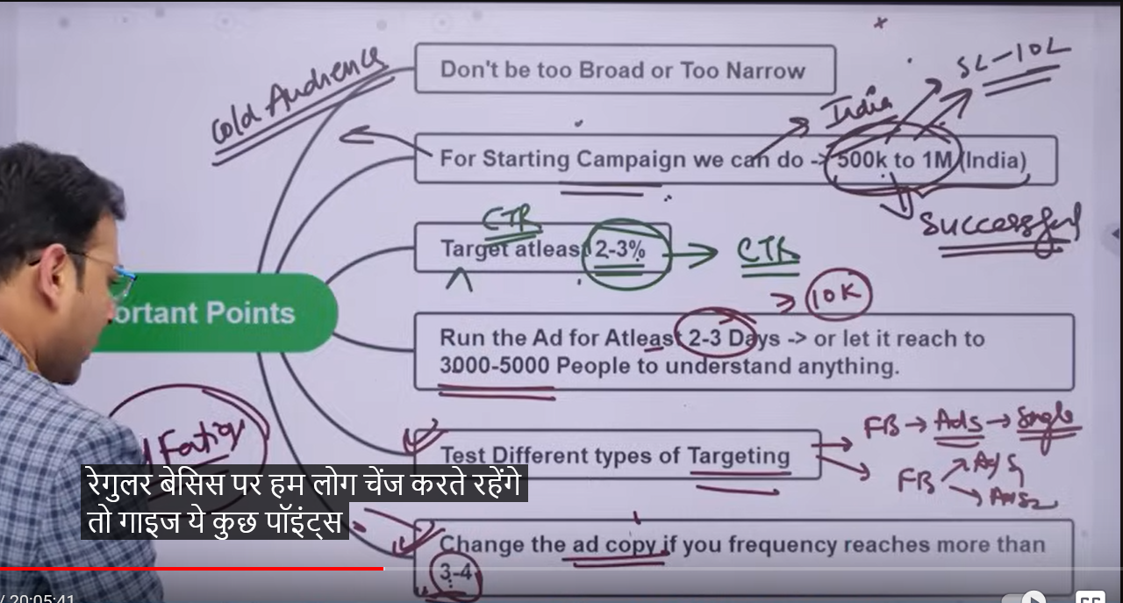

So these are the points of whatever we have talked about the audience till now.

**Lesson 35:-**

In this lesson we will learn about **How to write perfect ads copy**

If we talk about ad set level settings we have explored many option and settings there What are the things and how can we do audience targeting Now if we go by flow wise the next important thing is ad copy. The actual copy that will be shown to the people that is also very important and we have to focus on it

So we make sure here whenever we make Facebook ad account then the third level we have and where we make our actual ad creative what are the element there and how can we start

This topics is slightly related to copyrighting

If we talk about it talk about copyrighting then it is itself in in depth topic with regards to facebook ad it is indepth

So in future teacher will tell us about the copyright modals or framework

And we then use these framework to create our ad copy.

But first we need to see the elements we see in this level and what are the things we need to keep in mind means when we make our ad then what are things we need to collect what are the element you should have and then by uing that element we can create a better ad copy

Teacher is saying that this section is basically divided into two section

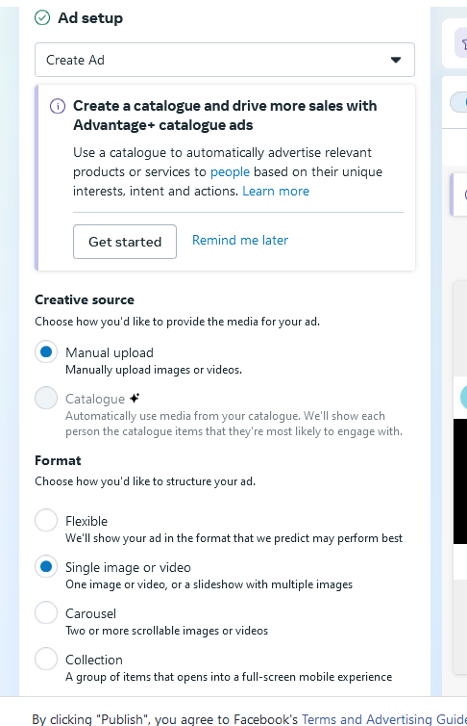

First we need to choose our format for example if you want to make a single image or video or you want to create a carousal if you want to you can make a carousal with different variety of combination of image or videos

Then we have collection type of format Mostly used format is single image or video so for now we choose single image or videos this is one section

Then the image or video we choose. what we see element related to it

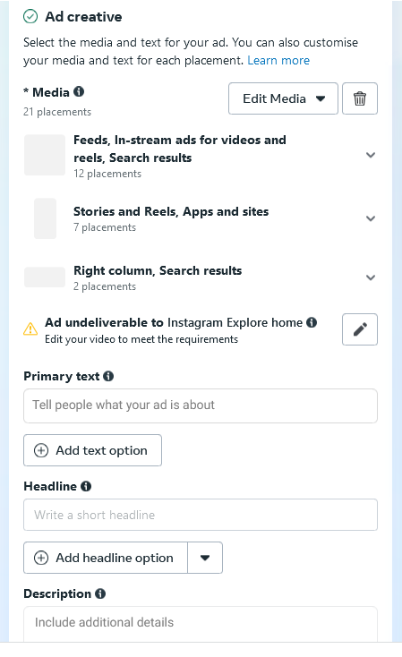

We see that there is that is primary text

It is the text you see above your creative 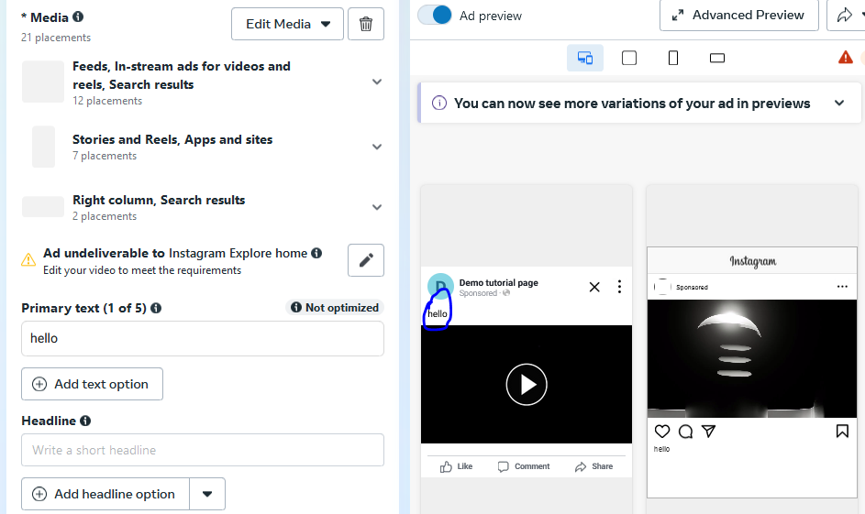

And in headlines you see the text below the creative

And yoy see the decription below the headlines as marked below

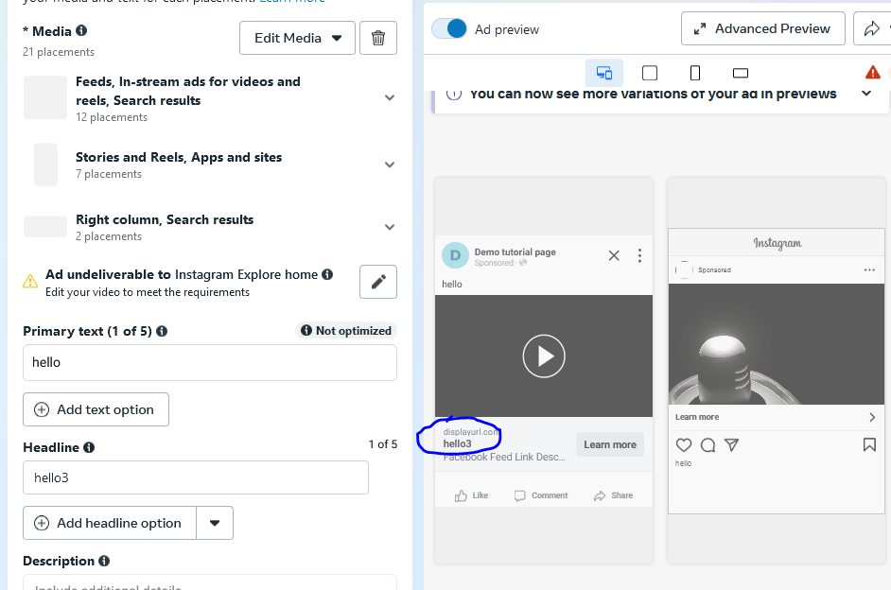

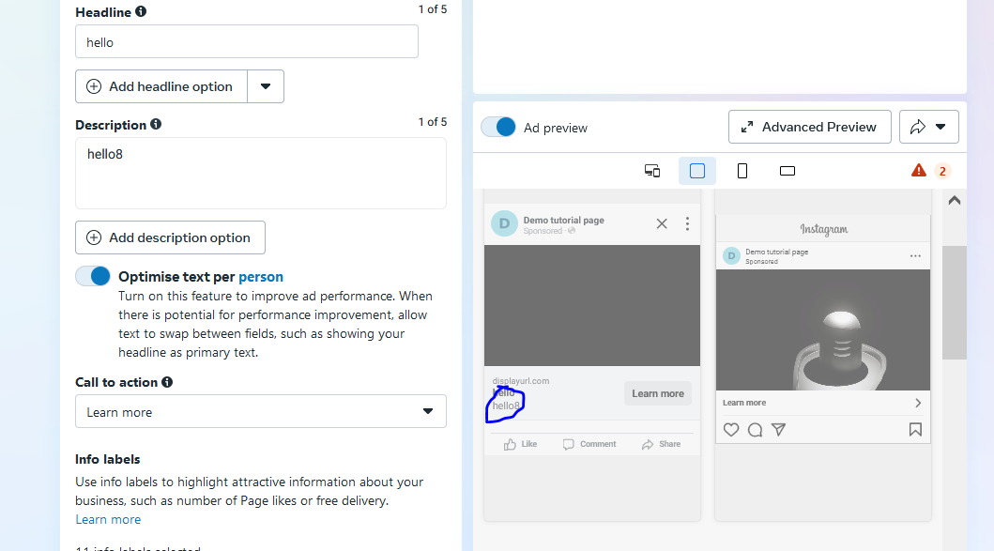

We also get option for our call to action button as you can se field of call to action

The most important thing is how we can write our primary test

First we discuss it firstly

What are the bullet points or things you need to keep in mind

There are three things our primary text need to have

First is hook

Basically people going to facebook is not coming to just see your ad

There just scroll and come across many ad then why should they click on your ad.

There should be attention grabbing or hook in our image or video

And by seeing that image it stops scrolling

In primary text it should have a hook type elements inside it

Which you thing It is an attention grabbing thing

And there should be something in text that when out targeted audience see iut they stop scrolling

Then we have story which is telling more about your story

Then the other thing is offer

Why should they watch your ad and landing page amd why should they purchase your offer so give offer to them

It is recommended to make customize offer whixh ou need to use for your app

If we talk about what are the things we can collect and keep inside them that is hook , offer, story So suppose if we take an example of hook then if we are selling digital marketing consultancy or google ad services

Who could be the your service consumer they could be business owners

The primary could be business owner

It is an example of hook type that does not mean hooks are of this type

Anything that can grab the attention of the viewr in facebook that is called hook.

**Phase 49**